**Research**

**Infographic**

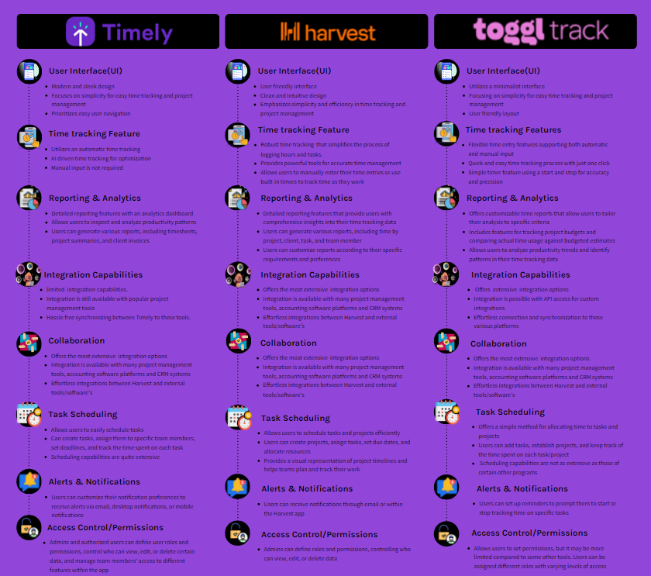

References

<https://www.getapp.com/finance-accounting-software/a/harvest/compare/toggl-vs-timely-app/>

<https://www.getapp.com/project-management-planning-software/a/toggl/>

<https://timelyapp.com>

<https://timelyapp.com/timely-features>

<https://www.getapp.com/project-management-planning-software/a/timely-app/>

<https://www.getharvest.com/resources/time-management-strategies>

<https://www.getapp.za.com/software/20571/harvest>

<https://project-management.com/harvest-software-review/>

<https://toggl.com/track/features/>

<https://toggl.com/track/pricing/>